
“Infostealer-Driven Session Hijacking and MFA Bypass: A Digital
Forensics Case Study of the Genesis Market Dark Web Marketplace Takedown (Operation Cookie Monster, 2023)”

BACHELOR OF TECHNOLOGY IN COUMPUTER SCIENCE AND ENGINEERING

Submitted By
Group Number: 36
Group Members:-
- Utsav Raj Singh (PRN: 23070122256)
- Sourav Singh (PRN:23070122257)
3.Sumit Pathak (PRN:23070122255)
Course: Cyber Security | Theory CA-2 (Part 2) | Case Study Report

UNDER THE GUIDANCE OF
Dr. Pooja Bagane
Professor

Pune – 412115, Maharashtra State, India https://www.sitpune.edu.in/

DEPARTMENT OF COMPUTER SCIENCE AND ENGINEERING
AY 2026

SYMBIOSIS INSTITUTE OF TECHNOLOGY, PUNE
Symbiosis International (Deemed University)

Abstract
Multi-factor authentication (MFA) is widely treated as the control that makes stolen passwords insufficient. This report examines a class of attack that sidesteps it entirely: infostealer malware copies the authenticated session state (cookies, tokens and browser profile data) from a victim's browser, and an attacker replays that state from another machine, inheriting an already completed MFA check. Genesis Market, a dark web marketplace active from 2018, industrialised this technique by selling per-victim packages of credentials, cookies and browser fingerprints, and was dismantled in April 2023 by an international law enforcement action named Operation Cookie Monster. Using the takedown as a single-case digital forensics study, we (i) reconstruct the attack chain and map it to MITRE ATT&CK, (ii) define the endpoint, identity-provider and marketplace-side artefacts an investigator would examine, following the NIST SP 800-86 phases, and (iii) evaluate detection of replayed sessions with three detectors on a synthetic log dataset of 20,400 sessions, because real marketplace evidence is not publicly available. A geo/IP-only rule reached an F1 score of 0.49, a weighted multi-signal rule reached 0.77 with 0.97 precision, and a logistic regression reached 0.98 recall. Detection against attackers who emulate the victim's browser depends mainly on whether the session lineage shows a fresh MFA event. We conclude that session-bound credentials, shorter token lifetimes, endpoint hygiene and cross-signal session monitoring are needed alongside MFA, and we discuss the limits of takedowns as a deterrent.
Keywords: infostealer, session hijacking, cookie theft, MFA bypass, Genesis Market,
Operation Cookie Monster, digital forensics, dark web marketplace, browser fingerprinting,
MITRE ATT&CK.

Introduction

Background
Passwords have long been the weakest link of online authentication [26], and the industry response has been to add a second factor such as a one-time code, push approval or hardware key. NIST guidance recognises multi-factor authenticators as materially stronger than passwords alone [36]. Yet the HTTP protocol is stateless, so after a user logs in, the server issues a session cookie or token and treats whoever presents it as the authenticated user [37], [38]. That token represents a bearer credential: if you’re holding it, you own it. Capture it from someone and you no longer need their password nor second factor.
It’s no surprise that malware families called “infostealers” have evolved to precisely extract this data from browsers and operating systems: passwords, cookies, autofill, cryptocurrency wallets and system information. [8][10] Victim reports analyzed by top-tier vendors and the FBI show stolen credentials/session theft popping up again and again in real-world incidents, targeting everything from enterprise identity providers to content creators. [5][6][12][14][15] Welcome to Genesis Market, where they commoditized it.

Case overview
Reported by Europol and the U.S. Department of Justice, Genesis Market was an online marketplace trading in access to hacked computers referred to as "bots", which has been operating since roughly 2018. Listings typically include account credentials bundled with cookies and browser fingerprint, allowing anyone who purchases access to successfully pose as the victim's browser and circumvent login challenges in most cases [1], [2]. Law enforcement seized control of the marketplace infrastructure on 4-5 April 2023 as part of an operation dubbed Cookie Monster, and made arrests and executed searches with partners from over 15 countries [1], [2].

Problem statement
Awareness material around MFA bypass tends to concentrate on phishing proxies. Far less attention has been paid to the commodity supply chain that powers session theft: infection > log collection > resale > replay. Viewing that chain through a forensics lens using an actual takedown as an anchor allows defenders to prioritize logging, triaging and controls that break the chain.

Objectives
- Written an article discussing session takeover defeating MFA, and why Genesis Market built harvestable.
- Reconstruct the attack chain and map it to MITRE ATT&CK techniques [8]-[11].
- Define a digital forensics workflow (NIST SP 800-86 [34]) for investigating a suspected hijacked session.
- Evaluate, on synthetic data, how well different detectors identify replayed sessions.
- Recommend technical and organisational countermeasures.

Relevance today
The topic stays current because takedowns have not removed the underlying model. Later actions against Lumma Stealer, RedLine and META and the wider Operation Endgame show that law enforcement and industry keep disrupting infostealer infrastructure [18]-[20], while browsers are deploying cookie-protection features such as app-bound encryption and devicebound session credentials [16], [17]. Annual crime statistics also show large and growing losses from online fraud and account compromise [3], [4], [7].

Literature Review

Stolen-data markets and the cybercrime economy
Criminology research describes stolen data markets as organised ecosystems with specialised sellers, buyers and trust mechanisms [30], [31]. Measurement studies of anonymous marketplaces document how they grow, fail and are replaced, and how listings are commoditised and priced [32], [33]. Genesis Market fits this pattern, but sells identity context rather than single records, which lowers the skill needed by the buyer. A crime-script view [31] is useful here: the buyer's steps are searching, purchasing, loading the profile and acting, each of which leaves different traces.

Credential theft vectors and infostealers
Thomas et al. compared data breaches, phishing and malware as sources of stolen credentials and showed that malware-based collection captures richer data, such as cookies and device details, than other vectors [21]. MITRE ATT&CK catalogues the relevant behaviours: stealing web session cookies (T1539), using a session cookie as alternate authentication material (T1550.004), credential theft from web browsers (T1555.003) and browser session hijacking (T1185) [8]-[11]. Operational reports describe distribution through malicious advertising, cracked software and phishing, followed by bulk exfiltration to command-andcontrol servers [14], [18], [20].

Cookie and session security research
Zheng et al. showed that cookies lack integrity protection against several network and application-layer attackers [22]. Drakonakis et al. built an automated auditor that found authentication and authorisation flaws in real sites' cookie handling [25]. Ghasemisharif et al. found that single sign-on accounts could be hijacked through weak session management and poor logout behaviour [24]. Squarcina et al. later demonstrated that cookie-handling inconsistencies can break session integrity and proposed mitigations [23]. These works concern flaws in the web platform; infostealer replay is different because the attacker holds a valid cookie, but the same defences (short lifetimes, rotation, binding) apply.

MFA and its limits
NIST SP 800-63B distinguishes authentication events from sessions and recommends session management controls such as re-authentication and reasonable lifetimes [36]. Microsoft Threat Intelligence documented adversary-in-the-middle phishing that captured session cookies after MFA was completed, then used them for business email compromise [12], and Microsoft incident responders described detection and response for cloud token theft [13]. The Okta support-system incident in 2023, involving session tokens exposed in support files, illustrates that tokens are sensitive wherever they are stored [15]. Senderconstrained tokens, for example OAuth DPoP, bind a token to a key held by the legitimate client [42].

Browser fingerprinting and its role in impersonation
Eckersley showed that browser configurations are often unique enough to identify users [27], and Laperdrix et al. surveyed fingerprinting techniques and defences [28]. Vastel et al. showed that fingerprints evolve gradually and can be linked over time [29]. This matters twice: sites use fingerprints to flag unfamiliar devices, and a marketplace that supplies the victim's fingerprint lets a buyer reduce that signal. Defenders therefore cannot rely on one fingerprint field alone.

Digital forensics frameworks
Palmer's DFRWS road map defines the stages of identification, preservation, collection, examination, analysis and presentation [41]. NIST SP 800-86 organises forensic work into collection, examination, analysis and reporting and explains how to integrate it with incident response [34], [35]. Standard texts cover digital evidence handling and file system analysis [39], [40], and Yin's method guides single-case study design [44].

Research gap
Literature discusses cookie security flaws, fingerprinting, and marketplace mechanics individually. Rarely are they connected in one forensic walkthrough of an observed marketplace arrest. This paper ties those pieces together and includes an open, reproducible detection methodology (limited by use of non-marketplace data).

Methodology

Research design
Our methodology combines a qualitative single-case study [44], with an applied forensic reconstruction, and a controlled simulation. The case (Genesis Market and Operation Cookie Monster) provides the real-world context and chain of events. The forensic reconstruction interprets that chain into what evidence an investigator would actually gather. The simulation then tests detection concepts without interacting with any real victim data or real attack tooling (both an ethical and legal requirement for a student project).

Evidence sources and reliability

Tier | Source type | Examples | Use
1  (primary) | Government and law enforcement releases | DOJ [1], Europol [2], FBI IC3  [3], [4] | Dates, scale, actors, charges
2  (technical) | Vendor and platform reports, standards | Microsoft [12], [13], Google  [14], [16], [17], MITRE [8]- [11],  NIST [34]-[36] | Technique  detail, controls
3  (scholarly  ) | Peer-reviewed and books | [21]-[33], [39]-[41], [44] | Concepts, methods
Table 1. Evidence tiers used in the case study.
Claims were retained only if supported by a Tier 1 or Tier 2 source. Figures such as arrest counts and credential volumes vary by publication date and outlet, so they are quoted from the primary releases [1], [2] and not recomputed. Court filings and seized-server evidence are not public; we therefore cannot reproduce marketplace internals and say so explicitly.

Forensic framework
The investigation workflow follows the four NIST SP 800-86 phases [34]: collection (preserve volatile and disk data, export identity-provider and proxy logs with hashes and chain of custody), examination (filter for session-related events), analysis (correlate endpoint and identity evidence into a timeline) and reporting. The phases are mapped to Palmer's stages [41] and to incident response practice [35].

Threat modelling and artefact catalogue
Each stage of the chain in Figure 1 was mapped to ATT&CK techniques and to the artefacts that stage leaves behind (Table 2). Artefacts are described at the level of what to examine, not how to exploit it.
Stage | ATT&CK  mapping | Key forensic artefacts
Infection | Initial access, user execution | Browser download history, installer hashes, email or ad referrer, AV/EDR alerts
Harvest | T1555.003, T1539  [8],  [10] | Process tree, file access to browser profile stores, short-lived staging archives, EDR telemetry
Exfiltration | Exfiltration over C2 | DNS and proxy logs, outbound connections to rare hosts, firewall records
Marketplace sale | Acquire/resell access | Listing metadata, seized database, payment ledger (law enforcement only)
Replay | T1550.004, T1185  [9],  [11] | IdP sign-in logs: new IP/ASN, user agent or  fingerprint change, session reuse without MFA prompt
Account takeover | Collection, impact | Mailbox rules, new MFA devices, OAuth grants, payment changes, audit logs
Table 2. Attack stages mapped to ATT&CK and forensic artefacts.

Detection experiment design
To evaluate what a defender can actually observe, we generated a synthetic dataset of 20,400 sessions: 20,000 legitimate and 400 replayed-cookie sessions (a 2% base rate, chosen for realism of class imbalance, not taken from any real statistic). Replayed sessions were drawn from three attacker profiles of increasing sophistication: naive (no attempt to match the victim), proxy+UA (a proxy in a similar region and a copied user agent) and full emulation (location, user agent and fingerprint largely matched). Probabilities for each profile are assumptions of the study and are not measurements of real attacks. Eight features were computed per session: ASN change, geographic distance, user-agent match, fingerprint match, concurrent use, session age at use, sensitive action (such as adding a forwarding rule), and whether the session lineage includes a fresh MFA event.
Period | Event | Source
c. 2018 | Genesis Market begins selling compromised-device access | [1], [2]
2018-2023 | Growth of the stealer-log economy; session cookies and fingerprints bundled per victim | [1], [2],  [31]
Apr 2023 | Operation Cookie Monster: domain seizure, arrests and searches coordinated internationally | [1], [2]
2022-2024 | Related abuse of stolen tokens in enterprise incidents | [12], [14],  [15]
2024-2025 | Further infostealer disruptions (Endgame, Magnus,  Lumma) | [18]-[20]
Three detectors were compared. Detector A flags distance above 500 km, a legacy impossible-travel rule. Detector B is a hand-weighted score over all eight signals with threshold 6. Detector C is class-weighted logistic regression [43] trained on a stratified 70% split and scored on remaining 30% (6,120 sessions, 120 of which are attacks).

Evaluation metrics
Precision, recall, F1, false positive rate (FPR) and ROC AUC are reported on held-out split, and recall is reported per attacker profile. Recall is important because missed hijacks are costly, FPR is important because every false alarm costs analyst time and may prevent legitimate users from accessing accounts.

Ethics and limitations
The study team did not access any real credentials, malware samples, marketplace content, or victim data. We relied only on public reporting and synthetic data. Results should be viewed as demonstrating the relative value of signals under the assumptions stated above, and should not be construed to mean detectors are this accurate in production.

Implementation Details

Chain reconstruction

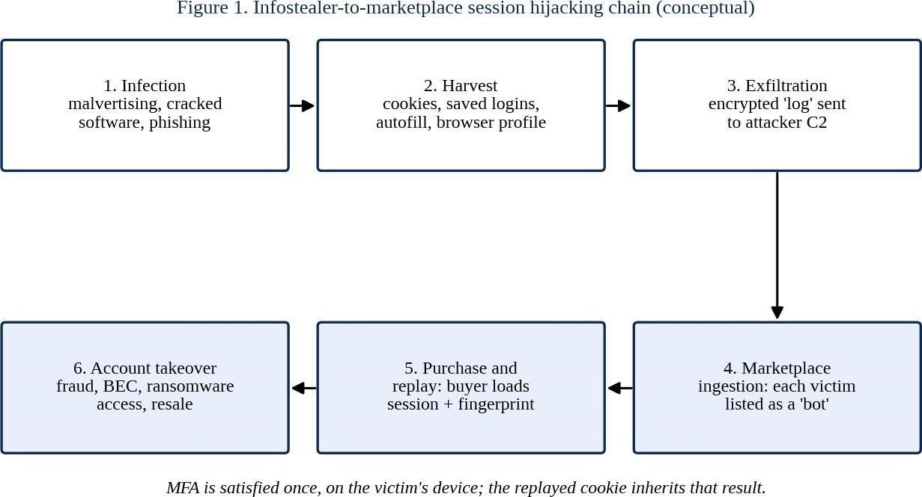

Figure 1. Chain Summary. Stage 1: victim installs malware or opens lure. Stage 2: stealer reads browser cookies / saved credentials. Stage 3: cookie and credential data are packaged and sent to the operator. Operators at Genesis Market processed such logs and displayed each one as a bot (with properties: country, services with logged-in sessions, price) where buyers could filter and select targets [1], [2]. Stage 5: buyer loads browser with cookies provided from marketplace then imported fingerprint profile via marketplace tool. Service sees a request with valid login session plus a reasonable facsimile of a browser. The bypass of MFA here is because the second-factor was validated already at initial login on the victim's device, at which point the cookie is the record of success.

Forensic investigation workflow
- Triage: either from an alert (impossible travel, new device, unexpected mailbox rule) or threat-intelligence match of an employee email address in a stealer-log dataset
- Preserve: export identity-provider sign-in and audit logs, proxy and DNS logs, and EDR telemetry; hash+timestamp each export; image/snaphot the presumed endpoint, if permitted by policy [34], [40].
- Investigate endpoint: analyze recent downloads/executions, look for unsigned processes accessing browser profile folders, and transient archives created before outbound transmissions.
- Investigate identity logs: replay each session ID/token chain; correlate IP, ASN, user agent, device ID, and MFA events between initial and subsequent uses.
- Correlate: line up the earliest suspect endpoint activity with the first outsider use of that session to measure theft-to-replay latency.
- Contain and report: terminate refresh tokens and sessions, reset passwords, re-register MFA, delete attacker-made rules / OAuth grants, and record your findings in the incident report [35].

Detection pipeline

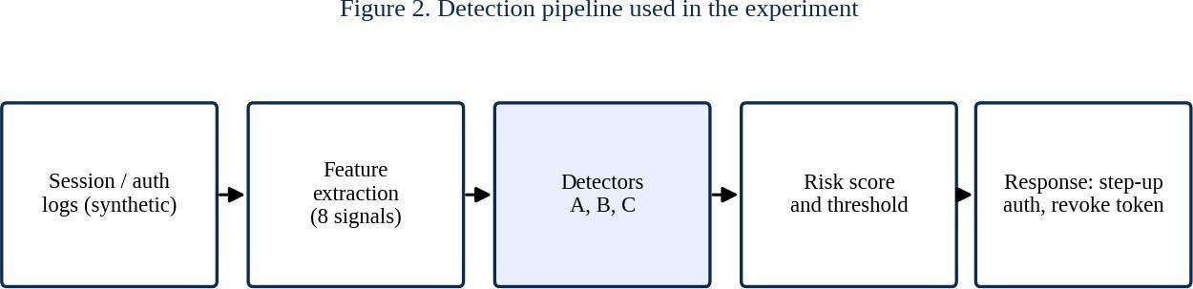

Pipeline described in Figure 2 has been implemented in Python 3 language using NumPy, pandas, scikit-learn 1.8.0 [43] and Matplotlib libraries. Fixed random seed ensures results are reproducible. Table 4 shows features used along with the reason they are expected to be beneficial.

Feature | Forensic rationale
ASN changed | Replay usually comes from a different network than the victim's
Distance (km) | Large jumps indicate different location; small ones can be proxied
User-agent match | Copied or mismatched agent strings reveal tooling
Fingerprint match | Attributes such as canvas, fonts, screen and timezone should be stable [27], [29]
Concurrent use | Victim and attacker active on one session at once
Session age | Stolen sessions are replayed hours to days later
Feature | Forensic rationale
Sensitive action | Mail forwarding rules, new MFA device, payout changes
Fresh MFA event | A replayed session never completed MFA itself
Table 4. Features session.

Controls mapped chain

Chain stage | Preventive / detective control
Infection | Application allow-listing, ad and download filtering, patching, user training on cracked software
Harvest | Browser cookie protection (app-bound encryption [16]), EDR rules for profile-store access
Exfiltration | Egress filtering, DNS monitoring, threat-intelligence blocklists
Replay | Device-bound sessions [17], DPoP [42], short token lifetimes, risk-based re-authentication [36]
Account takeover | Alerts on new MFA methods, mailbox rules and OAuth grants; fast token revocation
Table 5.mapped chain.

Results & Discussions

Case findings
The key take away is conceptual: MFA protects the authentication event, but not what happens in session afterward. Genesis Market monetised that gap by bundling the session and browser identity together [1], [2]. A second lesson is forensic in nature: since the attacker is presenting a valid cookie, the best form of forensic evidence is correlation across layers (endpoint execution, network exfiltration and identity-provider session lineage) rather than any single log. Finally, law enforcement was able to get evidence from the marketplace side of the operation. This is typically hidden from defenders, so organisations need to focus on the pieces they can see: identity and endpoint evidence.

Detection results

Detector | Precision | Recall | F1 | FPR | AUC
A: geo/IP only | 0.529 | 0.458 | 0.491 | 0.82% | 0.882
B: weighted rules | 0.975 | 0.642 | 0.774 | 0.03% | 0.990
C: logistic regression | 0.506 | 0.983 | 0.669 | 1.92% | 0.999
Table 6. Held-out results (6,120 sessions; 120 attacks). Synthetic data.
Detector A detected 55/120 attacks and produced 49 false alarms. This gives Detector A the lowest precision of all three detectors. Detector B is the most precise detector (only 2 false alarms) but missed 43 attacks. Detector C detected 118 out of 120 attacks at the cost of 115 false alarms (approximately one false alarm for each true alarm at this base rate).
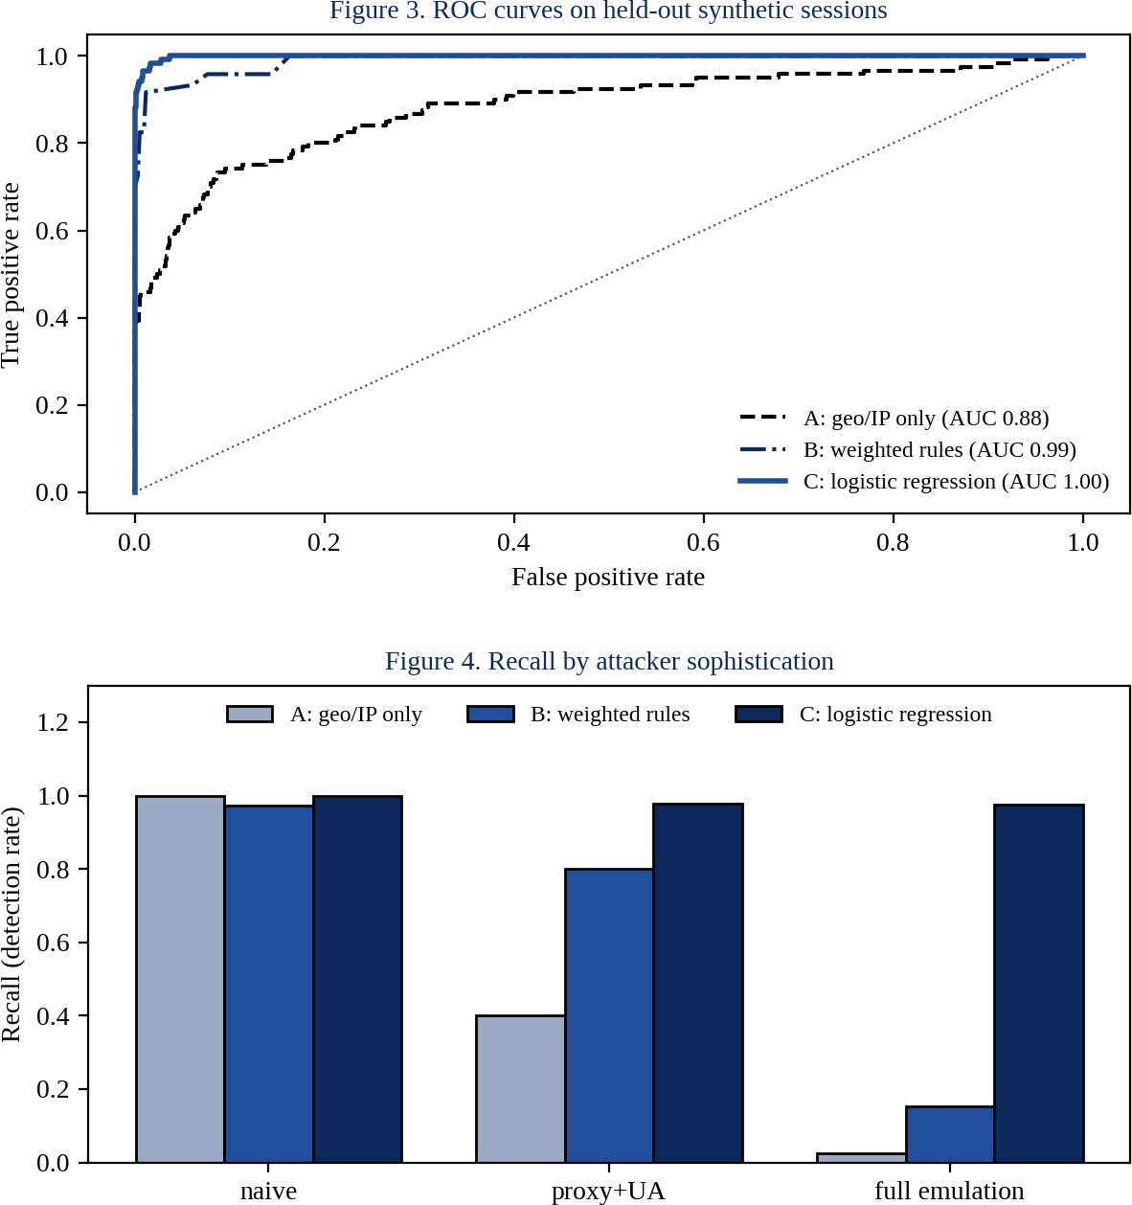
Recall by attacker profile demonstrates impact of sophistication. Against naive replay, all detectors performed similarly (A 1.00, B 0.97, C 1.00). Against proxy+UA, geo-only rule dropped to 0.40. Against full emulation, geo-only rule detected only 0.03 and weighted rule 0.15, while regression detected 0.97.

Discussion
We hypothesize that legacy impossible-travel detection is fragile because using a country-matched residential proxy obfuscates the signal it depends on. Signal fusion mitigates this, but it's not enough for the hand-tuned score to detect an attack where those aspects are also matched. The regression's reasonable recall against full emulation is unsurprising once you look at its coefficients: the fresh- MFA feature by itself overwhelms the rest (coefficient -8.7, versus 2.8 for ASN change). That feature basically encodes the intuition behind this case: a replayed session won't have its own authentication event.
There is an important caveat to this result. Legitimate sessions have a new MFA event 97% of the time in this simulated dataset, and attacks only have one 2% of the time. With "remember this device" options and long-lived refresh tokens enabled in the real system, there will be far more legitimate sessions that do not have recent MFA and this separation will be smaller. Therefore this experiment supports the relative conclusion that lineage aware signals contain information that network and browserattribute signals lose once the attacker can easily emulate them, not an absolute accuracy number. The attacker probabilities are likewise assumptions - a motivated attacker can game any published rule.

Effectiveness of the takedown
Taking down Genesis Market was good for removing one easy reseller and generating arrests and intel [1], [2]. However, there will always be new stolen logs as long as infostealer malware and buyers remain available. Follow-up actions against additional stealers and loaders [18]-[20] shows an ongoing, persistent effort that recognizes disruption increasing friction and splintering the market, something previous marketplace research might have forecast [32], [33]. Thus, defenders should consider takedowns as useful but only part of their own defense.

Recommendations
- Sessions should be bound to devices wherever possible (i.e. device-bound credentials [17], DPoP [42]) so that if a cookie is copied to another device, it becomes useless.
- Limit lifetime and rotate tokens, and if your system allows, require re-authentication for certain sensitive actions [36].
- Help secure endpoints by limiting unapproved software, implementing EDR detection rules focused on browser profile access and turning on browser features that encrypt cookies [16].
- Use session lineage tracking in your identity provider to alert on sensitive actions from sessions that don’t have a recent MFA event.
- Use breach-intelligence feeds to identify employee accounts present in stealer logs. When found, force session destruction and rotate credentials (not just passwords).
- Create your forensic playbook ahead of time: how long you retain sign-in logs, how you hash them, and chain of custody. [34],[35].

Limitations and future work
The study relies on public reporting and a synthetic dataset. Future work could validate the signals on anonymised enterprise telemetry, add sequence models over session history, test defences against adaptive attackers and study how stealer families responded to cookieencryption changes in browsers.

Conclusion
Genesis Market showed that MFA bypass does not need a clever exploit: it needs a valid session and a convincing browser identity, both of which infostealers can supply at scale. Operation Cookie Monster disrupted one marketplace and gave defenders a clear case to learn from. Our forensic reconstruction shows that investigations succeed by correlating endpoint, network and identity evidence, and our synthetic experiment shows that singlesignal detection such as impossible travel is fragile against emulation, whereas signals tied to the session's authentication history are more robust, within the stated assumptions. Organisations should combine device-bound sessions, token hygiene, endpoint protection and lineage-aware monitoring, and should treat any stolen-session finding as a reason to revoke sessions, not only reset passwords. References
- U.S. Department of Justice, "Criminal Marketplace Disrupted in International Cyber Operation," press release, Apr. 5, 2023.
- Europol, "Takedown of notorious hacker marketplace selling your digital identity," press release, Apr. 5, 2023.
- FBI Internet Crime Complaint Center (IC3), Internet Crime Report 2022, 2023.
- FBI Internet Crime Complaint Center (IC3), Internet Crime Report 2023, 2024.
- Verizon, 2023 Data Breach Investigations Report, 2023.
- Verizon, 2024 Data Breach Investigations Report, 2024.
- IBM Security, Cost of a Data Breach Report 2023, 2023.
- MITRE ATT&CK, "T1539: Steal Web Session Cookie," MITRE Corporation.
- MITRE ATT&CK, "T1550.004: Use Alternate Authentication Material: Web Session Cookie," MITRE Corporation.
- MITRE ATT&CK, "T1555.003: Credentials from Password Stores: Credentials from Web Browsers," MITRE Corporation.
- MITRE ATT&CK, "T1185: Browser Session Hijacking," MITRE Corporation.
- Microsoft Threat Intelligence, "From cookie theft to BEC: Attackers use AiTM phishing sites as entry point to further financial fraud," Microsoft Security Blog, Jul. 2022.
- Microsoft Incident Response, "Token tactics: How to prevent, detect, and respond to cloud token theft," Microsoft Security Blog, 2022.
- Google Threat Analysis Group, "Phishing campaign targets YouTube creators with cookie theft malware," Google blog, 2022.
- Okta, "Tracking Unauthorized Access to Okta's Support System," security advisory, Oct. 2023.
- Chromium Security Team, "Improving the security of Chrome cookies on Windows," Chromium Security Blog, Jul. 2024.
- Google Chrome Team, "Device Bound Session Credentials (DBSC)," Chromium explainer and proposal, 2024.
- Microsoft Digital Crimes Unit, "Disrupting Lumma Stealer: Microsoft leads global action against favored cybercrime tool," Microsoft On the Issues, May 2025.
- Europol, "Operation Endgame" coordinated action against malware droppers and loaders, May 2024.
- Europol and Dutch National Police, "Operation Magnus": disruption of RedLine and META infostealers, Oct. 2024.
- K. Thomas et al., "Data Breaches, Phishing, or Malware? Understanding the Risks of Stolen Credentials," in Proc. ACM CCS, 2017.
- Y. Zheng et al., "Cookies Lack Integrity: Real-World Implications," in Proc. USENIX Security Symposium, 2015.
- M. Squarcina et al., "Cookie Crumbles: Breaking and Fixing Web Session Integrity," in Proc. USENIX Security Symposium, 2023.
- M. Ghasemisharif et al., "O Single Sign-Off, Where Art Thou? An Empirical Analysis of Single Sign-On Account Hijacking and Session Management on the Web," in Proc. USENIX Security Symposium, 2018.
- M. Drakonakis, S. Ioannidis and J. Polakis, "The Cookie Hunter: Automated
Black-box Auditing for Web Authentication and Authorization Flaws," in Proc. ACM
CCS, 2020.
- J. Bonneau, C. Herley, P. van Oorschot and F. Stajano, "The Quest to Replace Passwords: A Framework for Comparative Evaluation of Web Authentication Schemes," in Proc. IEEE Symposium on Security and Privacy, 2012.
- P. Eckersley, "How Unique Is Your Web Browser?," in Proc. Privacy Enhancing Technologies Symposium (PETS), 2010.
- P. Laperdrix, N. Bielova, B. Baudry and G. Avoine, "Browser Fingerprinting: A Survey," ACM Transactions on the Web, vol. 14, no. 2, 2020.
- A. Vastel, P. Laperdrix, W. Rudametkin and R. Rouvoy, "FP-STALKER: Tracking Browser Fingerprint Evolutions," in Proc. IEEE Symposium on Security and Privacy, 2018.
- T. J. Holt, "Exploring the Social Organisation and Structure of Stolen Data Markets," Global Crime, vol. 14, no. 2-3, 2013.
- M. Hutchings and T. J. Holt, "A Crime Script Analysis of the Online Stolen Data Market," British Journal of Criminology, vol. 55, no. 3, 2015.
- K. Soska and N. Christin, "Measuring the Longitudinal Evolution of the Online Anonymous Marketplace Ecosystem," in Proc. USENIX Security Symposium, 2015.
- R. van Wegberg et al., "Plug and Prey? Measuring the Commoditization of Cybercrime via Online Anonymous Markets," in Proc. USENIX Security Symposium, 2018.
- K. Kent, S. Chevalier, T. Grance and H. Dang, Guide to Integrating Forensic Techniques into Incident Response, NIST SP 800-86, 2006.
- P. Cichonski, T. Millar, T. Grance and K. Scarfone, Computer Security Incident Handling Guide, NIST SP 800-61 Rev. 2, 2012.
- P. Grassi et al., Digital Identity Guidelines: Authentication and Lifecycle Management, NIST SP 800-63B, 2017.
- A. Barth, "HTTP State Management Mechanism," IETF RFC 6265, 2011.
- OWASP Foundation, "Session Management Cheat Sheet," OWASP Cheat Sheet
Series.
- E. Casey, Digital Evidence and Computer Crime, 3rd ed. Academic Press, 2011.
- B. Carrier, File System Forensic Analysis. Addison-Wesley, 2005.
- G. Palmer, "A Road Map for Digital Forensic Research," DFRWS Technical Report DTR-T001-01, 2001.
- D. Fett et al., "OAuth 2.0 Demonstrating Proof of Possession (DPoP)," IETF RFC 9449, 2023.
- F. Pedregosa et al., "Scikit-learn: Machine Learning in Python," Journal of Machine Learning Research, vol. 12, 2011.
- R. K. Yin, Case Study Research and Applications: Design and Methods, 6th ed. SAGE, 2018.

